*International Conference on Mechanical Sciences, 12-13 Nov. 2021*

|  |  |  |
| --- | --- | --- |
|  | **University Larbi Ben M’Hidi of Oum El Bouaghi**  Sciences and Applied Sciences Faculty  The Mechanical engineering Department in collaboration with CMASMTF Laboratory  ***International Conference on Mechanical Sciences*** |  |

Title of your paper (Times New Roman 16 pixels, left justified)

First Author a, Second Author b, Third Author a,b,* (Times New Roman, 12 pixels)

a First affiliation, Address, City, Country (Times New Roman, 10 pixels)

b Second affiliation, Address, City, Country (Times New Roman, 10 pixels)

* Corresponding author, E-mail address:

Tel.: + ___ ____________

**Abstract**

Papers are accepted in Arabic, English and French. The paper full length should be 4000-7000 words. The paper file name is composed of the author name, surname and thematic (name-surname-Ti.docx, thematic i=1 to 4). Every paper must be attended by an abstract concise and factual. A maximum of **200 words** with no abbreviations or acronyms is recommended. Your Abstract here (Times New Roman 10 pixels, justified), Your Abstract here (Times New Roman 10 pixels, justified), Your Abstract here (Times New Roman 10 pixels, justified), Your Abstract here (Times New Roman 10 pixels, justified), Your Abstract here (Times New Roman 10 pixels, justified), Your Abstract here (Times New Roman 10 pixels, justified), Your Abstract here (Times New Roman 10 pixels, justified), Your Abstract here (Times New Roman 10 pixels, justified), Your Abstract here (Times New Roman 10 pixels, justified),

**Keywords:** Keywords, Keywords, Keywords, Keywords, Keywords, Keywords (New Roman 10 pixels)

**1. Introduction** (New Roman, bold, 12 pixels)

The manuscript must be written on standard paper (A4 format) in 1.5 interline spacing format with margins of 3 cm on each side [1], justified on the right and on the left and on the front only. The manuscript must be written on standard paper (A4 format) in 1.5 interline spacing format with margins of 3 cm on each side, justified on the right and on the left and on the front only [2]. (New Roman, 12 pixels).

**2. Title of the section** (New Roman, bold, 12 pixels)

The article should be divided, clearly defined and numbered into sections (New Roman, 12 pixels)

2.1 Title of the subsection (New Roman, 12 pixels)

Enter here the text of subsection. Enter here the text of subsection. Enter here the text of subsection. Enter here the text of subsection. Enter here the text of subsection. Enter here the text of subsection. Enter here the text of subsection. Enter here the text of subsection. Enter here the text of subsection. Enter here the text of subsection. Enter here the text of subsection. Enter here the text of subsection. (New Roman, 12 pixels)

2.1.1 Title of the second subsection (New Roman, 12 pixels)

Enter here the text of second subsection. Enter here the text of second subsection. Enter here the text of second subsection. Enter here the text of second subsection. Enter here the text of second subsection. Enter here the text of second subsection. Enter here the text of second subsection. (New Roman, 12 pixels)

**3. Results and discussion** (New Roman, bold, 12 pixels)

Enter your results in this section. Figures should be clear, as explicit as possible and numbered in the text. In addition, each illustration must have a legend and include a minimum but explain all the symbols and abbreviations used (Fig. 1).

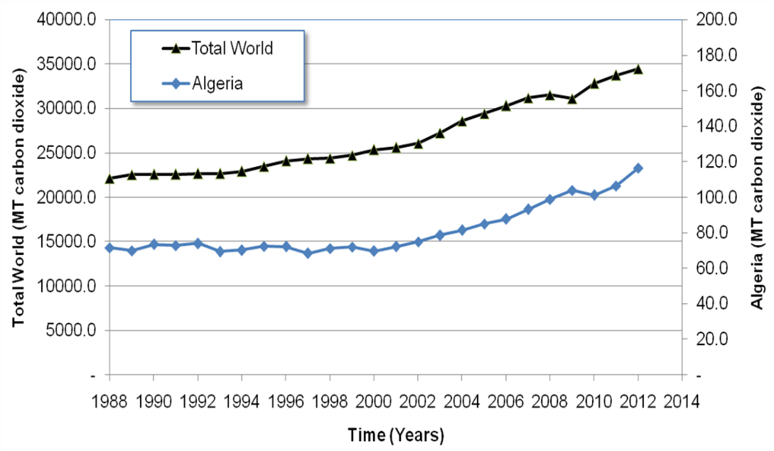

Fig 1. Total Greenhouse gas emissions in Algeria

Tables should be numbered in the text and presented as editable text and not as images. The data presented in tables do not duplicate results described elsewhere in the article (Table 1).

Table 1. Algeria's energy consumption by source in 2015

|  |  |  |  |
| --- | --- | --- | --- |
| Energy by source | Energy consumption (MTOE) | | |
| 2005 | 2010 | 2015 |
| Oil | 11.034 | 14.835 | 19.302 |
| Natural Gas | 20.904 | 23.683 | 35.118 |
| Coal | 0.594 | 0.310 | 0.179 |
| Nuclear | 0.000 | 0.000 | 0.000 |
| Hydroelectricity | 0.126 | 0.039 | 0.033 |
| Renewables | 0.000 | 0.002 | 0.018 |
| total consumption | 32.6583 | 38.8688 | 54.6495 |

Please use this paragraph to type the table footer(s) if any.

**Appendix**

Appendixes, if needed, appear before the acknowledgment.

## Figures and Tables

Please verify that the figures and tables you mention in the text actually exist. Place figure captions below the figures; place table titles above the tables. If your figure has two parts, include the labels “(a)” and “(b)” as part of the artwork.

Please do not include captions as part of the figures. Do not put borders around the outside of your **figures.** Use the abbreviation “Fig.” even at the beginning of a sentence.

## References

Number citations consecutively in square brackets [1]. Multiple references [2,3] are each numbered with separate brackets [1–3].

In the reference list given below, give all authors’ names; do not use “*et al*.” unless there are six authors or more.

## Equations

Number equations consecutively with equation numbers in parentheses flush with the right margin, as in (1). First use the equation editor to create the equation.

 (1)

**4. Conclusions** (New Roman, bold, 12 pixels)

Present here the most important conclusions of the article. Present here the most important conclusions of the article. Present here the most important conclusions of the article. Present here the most important conclusions of the article. (New Roman, 12 pixels)

**5. Acknowledgements** (New Roman, bold, 12 pixels)

If it exists, present here the acknowledgments (New Roman, 12 pixels)

**6. References** (New Roman, bold, 12 pixels)

*Example of Reference to a journal publication:*

[1] Chae KJ, Kim IS, Ren X, Cheon KH. Reliable energy recovery in an existing municipal wastewater treatment plant with a flow-variable micro-hydropower system. Energy Convers Manag 2015;101:681–8. doi:10.1016/j.enconman.2015.06.016.

*Example of Reference to a book:*

[2] Strunk Jr W, White G. The elements of style. 3th ed. New York: Longman; 2018.

*Example of Reference to a chapter in an edited book:*

[3] Wang H., Adams LB. J. Renewable Energies. In: Jones BS, Smith RZ, editors. Names of editors, New York: E-Publishing Inc; 2009, p. 165–234.

*Example of Reference to a website:*

[4] Energy situation in Algeria. General reports for Algeria, http://www.energyreports.org/statistics/; 2003 [accessed 15 March 2020].