Corrigé type session rattrapage : Math 03

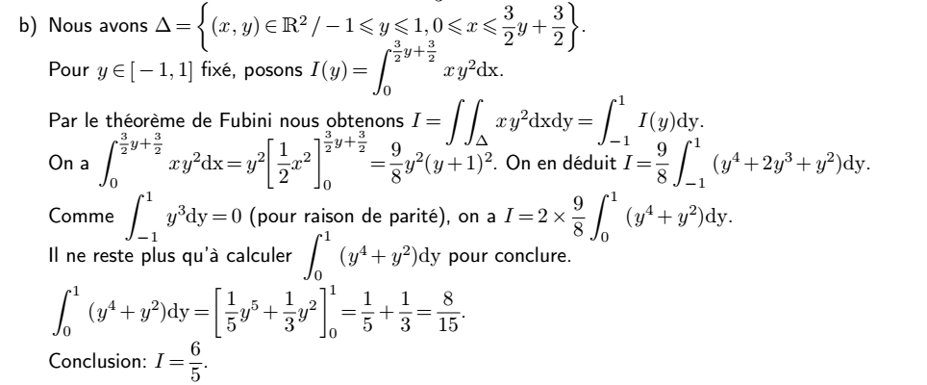
4pts

2pts

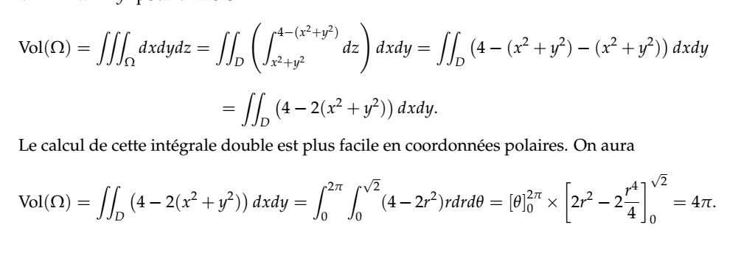
4pts

2pts

2.5pts
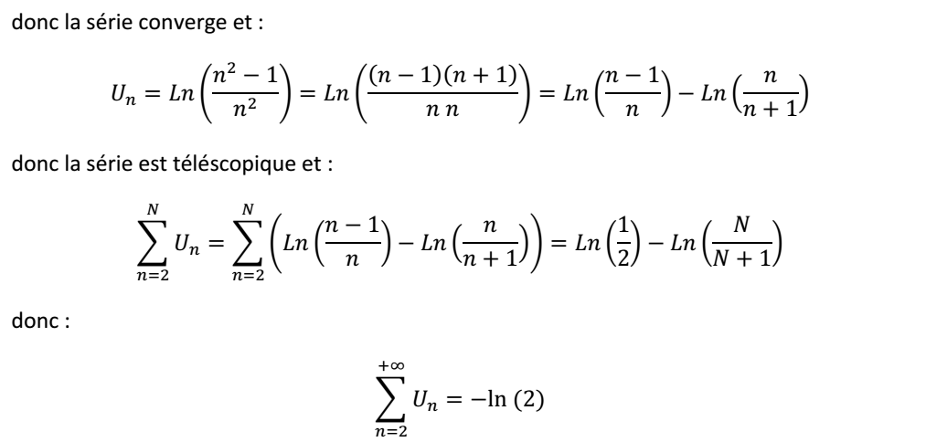
3pts

2.5pts
