
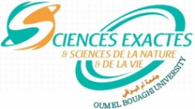
University of Larbi Ben M'Hidi Oum El Bouaghi
Faculty of Exact Sciences and Natural and Life Sciences
Department of Natural and Life Sciences

Programme consultation M1 BPR

Enseignant | Module | Date | Heure | Salle
BOULAHBEL | Histologie spéciale | 26-01-2026 | 9h00 | I 2
OULDJAOUI | Biologie moléculaire | 28-01-2026 | 12h30 | I 2
REDOUANE | Toxicologie et agents pathogène | 25-01-2026 | 12h30 | I 3
MOUMEN | Immunologie | 29-01-2026 | 10h00 | I 2
KHANFER | Informatique | 25-01-2026 | 11h00 | I 2
MANSOURI | Communication | 28-01-2026 | 11h00 | I 2

