Marking Scheme of the Genetic Exam
3

- Indicate whether each of the following statements is True (T) or False (F).
- T | - T | - F | - F | - F | - T
- Check the correct answer 2.اختر الاجابة الصحيحة
1.5

a. ❏ 3’-UTR b. ❏ Pachytene c. ❏ Nonsense or ❏ Frameshift
1
- Gametes : 20, Trisomic : 41, Nullisomic : 38, Somatic cells : 40
0.5
- Give an example of spontaneous chemical changes that cause mutations?
4. أذكر نوعا من التغييرات الكيميائية التلقائية و التي تسبب..................؟ deamination, depurination, tautomeric shifts.
0.5
- DNA ligase: Weld together Okazaki fragments.
0.5
Primase: Synthesizes the RNA primer.
0.5
- Prophage: Phage genome that has been integrated into a DNA of bacterial host.
0.5
Mutagen: Anything that causes a mutation.
1

Jacob syndrome | Patau syndrome
Sex chromosome trisomy - XYY- Males | Autosomal trisomy, +13, Males or females
Exercice 01:
- F₁ indicate that: The type of dominance is the complete dominance for the two trait and the parents are homozygous
1

Yes the two genes are linked  Justification: Parentals: 457 + 494 = 951  1  Recombinants: 21 +28 = 49  Parentals >> Recombinants | 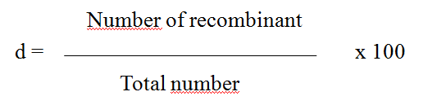  0.5  d = 49 x100 / 1000 d = 4.9 cM

Genotype of the parents : | r B R b  1  ---------- x ----------  r B R b
Genotype of the F₁ : | r B  0.5  ---------  R b
Genotype of the F₂ : | r B R b R B r b  1  ---------- , ---------- , --------- , ---------  r b r b r b r b
Exercise 02:
- Yes, the gene is X-linked
1
Justification: in F₁, we have different phenotypes between males and females.
1
- Complete dominance, in F1 generation female has a grey.

 | Male | Female
The genotype of the parents: | X^{G} Y | X^{g} X^{g}  1
The genotype of the F₁ : | X^{g} Y | X^{G} X^{g}  1
The genotype of the F₂: | X^{G} Y, X^{g} Y | X^{G} X^{g} , X^{g} X^{g}  2

