University of Larbi Ben M’Hidi-Oum El Bouaghi
Faculty of Exact Sciences and Natural and Life Sciences
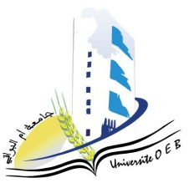
Department: Material Science
Field: Chemistry
Specialty: Analytical Chemistry

Master's Degree 2

Day and date | Time | Subject | Teacher | Room
Tuesday  27-01-2026 | 09 :00-09 :30 | Environmental Aspects | Hamada | D 02
Sunday  25-01-2026 | 11 :30-12 :00 | Analysis Techniques in Electrochemistry | Hafsi | D 2
Tuesday  27-01-2026 | 09 :00-09 :30 | Applied Numerical Methods | Laich | D 2
Wednesday  28-01-2026 | 90h00-09:30 | Organization and Management of Companies | Habbes | D 2
Thursday  15-01-2026 | 09 :30-10 :00 | Analyses Related to the Environment II | Gherraf | D 2
Tuesday  17-01-2026 | 10 :00-110h30 | PersonalDocumentary Research Work | Nacer | D 2
Sunday  25-01-2026 | 13 :00-14 :30 | Spectrometry and Imaging Instrumentation II | Azizi, S | D 2
Wednesday  28-01-2026 | 10 :00-10 :30 | Health and Safety | DemmeneDebbih | D 2
Academic year2025-2026.

