Larbi Ben M'HidiUniversity - Oum El Bouaghi
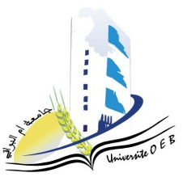
Faculty of Exact Sciences and Natural and Life Sciences
Department: of Science of matter

Field of Study:Chemistry
Specialty: Pharmaceutical Chemistry

Master's Degree 2

Day and date | Time | Subject | Teacher | Room
sunday  25-01-2026 | 10H00-110H30 | Bioethic | allaoua | D2
TUESDAY  11-02-2026 | 12H00-12H00 | Industrialhygiene and safety in pharmaceutical sites | Hazourli | D2
Tuesday  27-01-2026 | 12H00-12H30 | Microbiology | Saouli | D2
sunday  25-01-2026 | 11H00-11H30 | Marketing authorization (AMM) | Mahdi | D2
sunday  25-01-2026 | 11H30-12H00 | Chemistry of naturalproducts | SID | D2
Tuesday  27-01-2026 | 10H00-10H30 | Chemistry of drugs | Demmene Debbih | D2
MONDAY  26-01-2026 | 13H00-14H30 | Economy and business management | Habbes | D 2

Academic year2025-2026.

