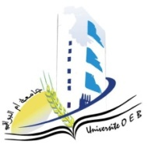
Larbi Ben M’Hidi University – Oum El Bouaghi
Faculty of Exact Sciences and Natural and Life Sciences
Department: Material Science
Field of study: Chemistry]
Specialty: Materials Chemistry Master's Degree 2

Day and date | Time | Subject | Teacher | room
tuesday  10-01-2026 | 09H00-09H30 | Personal bibliographic research work  English | Berrah | F1
Sunday  25-01-2026 | 11H00-11H30 | Materials characterization method 2 | Bouacida | F1
monday  26-01-2026 | 09H00- 09H30 | Applied numerical methods | Laiche | F1
monday  26-01-2026 | 09H30-10H00 | Introduction to research | Zendaoui | F1
Monday  26-01-2026 | 10H00-10H30 | Civil law | Haouili | F1

Academic year2025-2026.

