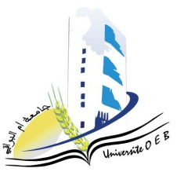
Larbi Ben M’HidiUniversity - Oum El Bouaghi
Faculty of Exact Sciences and Natural and Life Sciences
Department : Material Science

Field : Physics

Specialty: Materials Physics Master's Degree 2

Day and date | time | Subject | Teacher | room
sunday  10-01-2026 | 10H00-10H30 |  | boudabe | D1
  Nanotehnology
Sunday  11-01-2026 | 11H00-11H30 | Physics of defects | mecif | D1
Tuesday  13-01-2026 | 11H00-11H30 | Scientific processes and didactics  Methods of analysis and characterization of materials | mahdjoub | D1
Wednesday  14-01-2026 | 13H00-14H30 | english | bensalah | D1
Thursday  15-01-2026 | 13H00-14H30 | Thermodynamics and statistical physics | Khanchoul | D1
Thursday  15-01-2026 | 13H00-14H30 | Applied numerical methods | laich | D1

Academic year2025-2026.

