Larbi Ben M'HidiUniversity - Oum El Bouaghi
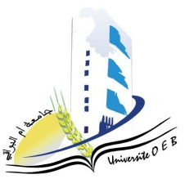
Faculty of Exact Sciences and Natural and Life Sciences
Department: of Science of matter

Field of Study:Chemistry

Specialty: Pharmaceutical Chemistry
Master 1

Day and date | Time | Subject | Teacher | room
Tuesday  27-01-2026 | 11H00-11H30 | Pharmaceutical legislation and ethics  Drug Technology – Galenic Pharmacy | ABABSA Z | D 5
monday  26-01-2026 | 09H00-10H30 | Spectroscopic Analysis Methods | Azizi S | D 5
sunday  25-01-2026 | 09H00-10H30 | Heterocyclic Organic Chemistry | SID | D 5
monday  26-01-2026 | 09H00-10H30 | Chemical Reactors and Bioreactors | Bouasida | D5
monday  26-01-2026 | 09H00-10H30 | Pw Physico chemical Extraction and Analysis | Berahel | D5
Sunday  25-01-2026 | 09H00-10H30 | Molécules bioactives - Méthodes d’extraction | Zater | D5
Tuesday  27-01-2026 | 09H00-10H30 | Biochemistry – Microbiology | Saouli | D5
Thursday  29-01-2026 | 09H00-10H30 | PW Intelligence artificielle et Machine Learning 1 | Bensiah | D5

Student groups are assigned to exam rooms as follows:

Student Group | Room
Group : 01 | D 07
Group : 02 | D 06
Academic Year 2025-2026.

