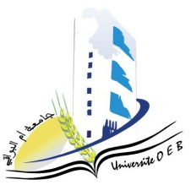
Larbi Ben M’Hidi University – Oum El Bouaghi
Faculty of Exact Sciences and Natural and Life Sciences
Department: Material Science
Field of study: Chemistry]
Specialty: Analytical Chemistry Master's Degree 1
Day and date | Time | Subject | Teacher | Room
Sunday  25-01-2026 | 11H00-11H30 | PW ChromatographicAnalysisMethods | Golia | D 4
monday  26-01-2026 | 11H30-12H00 | Chemistry–Physics of Surfaces and Interfaces  PW Electrochemical Applications | Hazourli | D 4
Wednesday  28-01-2026 | 11H00-11H30 | BibliographicSynthesis and Writing Chromatographic Analysis Techniques | Nacer | D 4
sunday  25-01-2026 | 11H30-12H00 | Analytical Electrochemistry | Anana | D 4
Thursday  29-01-2026 | 09H00-10H30 | PW Programming in Analytical Chemistry  PW Artificial Intelligence and Machine Learning 1 | Bensiah | D 4
Tuesday  27-01-2026 | 11H00-11H30 | Environmental Analyses  Multi‑equilibria in Solution | Hamada | D 4
Academic year2025-2026

