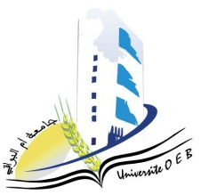
Larbi Ben M’HidiUniversity - Oum El Bouaghi
Faculty of Exact Sciences and Natural and Life Sciences
Department : Material Science

Field : Physics

Specialty: Materials Physics Master's Degree 1

Jour et date | Time | Subject | Teacher | room
Tuesday  27-01-2026 | 11H00-11H30 | Artificial intelligence and machine learning 1 | benSaihe | D7
sunday  25-01-2026 | 12H30-13H00 | Advanced Solid State Physics | Benhamla | D07
monday  26-01-2026 | 09H00-10H30 | Physics of semiconductors | hobar | D 07
Monday  26-01-2026 | 11H30-12H00 | exploration of free and open source software Physical Production and storage of hydrogen/ | Khanchoule | D 07
Wednesday  28-01-2026 | 11H00-11H30 | radiation-matter | malouki | D 07
sunday  25-01-2026 | 13H00-13H30 | Dielectric and magnetic materials | Khanchoule | D 07
Wednesday  28-01-2026 | 11H30-12H00 | Physical metallurgy | Goumeidane | D 07
tuesday  27-01-2026 | 11H30-12H00 | Signal processing | Laib | D 07

Academic year2025-2026

