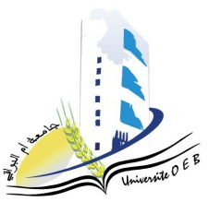
Larbi Ben M’Hidi University – Oum El Bouaghi
Faculty of Exact Sciences and Natural and Life Sciences
Department: Matter Science
Program: Physics
Specialty: Fundamental Physics
Year: $3^{rd}$Year
Day & Date | Time | Subject | Instructor | Room
Sunday  25/01/2025 | 08:30–09:00 | Acoustics | Bordji | F4
Sunday  25/01/2025 | 09:00–19:30 | Quantum Mechanics II | Zeroual | F4
Sunday  25/01/2025 | 12:30–13:00 | Special Relativity | Abdellaoui | F4
monday  26/01/2025 | 11:00–11:30 | Semiconductor | Kalla | F4
Tuesday  27/01/2025 | 11:30–12:00 | Digital Physics | Boudjamaa | F4
Tuesday  27/01/2025 | 11:00–11:30 | Statistical Physics | Merad | F4
Wednesday  28/01/2025 | 11:30–12:00 | Special Functions of Physics | Zeroual | F4
Wednesday  28/01/2025 | 11:00–11:30 | Entrepreneurship | Habes | F4
— | —

