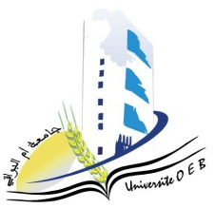
University of Larbi Ben M’Hidi-Oum El Bouaghi
Faculty of Exact Sciences and Natural and Life Sciences
Departement: Sciences Of Matter

Planning of semester 5 exams

Field of study: chemistry
Specialization: pharmaceutical chemistry

3rd year

Day and date | Hour | Matter | Teacher | Place
Sunday  25-01-2026 | 11H00-11H30 | SpectroscopicMethods of Analysis | Hafsi | D 08
Sunday  25-01-2026 | 11H30-12H00 | PW Pharmacology-Toxicology | Mahdi | D 08
monday  26-01-2026 | 11H00-11H30 | PW : ElectrochemicalAnalysisMethods | Hazourli | D 08
monday  26-01-2026 | 11H00-11H30 | Pharmaceutical OrganicChemistry | Berhail | D 08
Tuesday  27-01-2026 | 11H30-12H30 | Introduction to Knowledge of Medicine | Ababsa | D 08
Wednesday  28-01-2026 | 11H00-11H30 | Advanced OrganicChemistry I | Lafrada | D 08
Wednesday  28-01-2026 | 12H30-13H00 | Entrepreneurship | Habes | D 08

Academic Year 2025-2026

