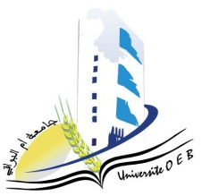
Larbi Ben M'Hidi-Oum El Bouaghi University

Faculty of Exact Sciences and Natural and Life Sciences

Department: Materials Science

Field of study: Chemistry

Specialisation: Fundamental Chemistry 3rd year

Day and date | Time | Matter | Teacher | Room
Sunday  25-01-2026 | 09H00-10H30 | Molecular Spectroscopy | zouchoune | D3
Monday  26-01-2026 | 09H00-10H30 | Analytical Chemistry | bouchane | D3
Monday  26-01-2026 | 09H00-10H30 | Materials Chemistry | bouchane | D3
Tuesday  27-01-2026 | 11H00-11H30 | Organic Chemistry | Allaoua | D3
Wednesday  28--01-2026 | 11H00-11H30 | Thermodynamics of solutions | hamimed | D3
Thursday  28--01-2026 | 11H30-12H00 | Entrepreneurship | habes | D3

University Year 2025-2026.

