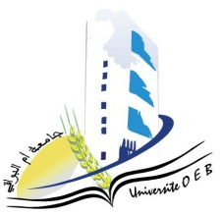
Larbi Ben M’HidiUniversity - Oum El Bouaghi
Faculty of Exact Sciences and Natural and Life Sciences
Department : Material Science

Field : Physics

Specialty: Materials Physics 3rd year

Day and date | Time | Subject | Teacher | Room
Sunday  25-01-2026 | 12H30-13H00 | Solid state physics 1 | Benhamla | F 02
monday  26-01-2026 | 12H30-13H00 | Mathematics for Physics | Hamouda | F 02
Tuesday  27-01-2026 | 11H00-11H30 | Numeric alanalysis | Laiche | F02
Tuesday  27-01-2026 | 11H30-12H00 | Quantum mechanics 2 | Abdalaoui | F 02
Wednesday  28-01-2026 | 11H00-11H30 | Component Electronics | Bordji | F 02
Wednesday  28-01-2026 | 11H30-12H00 | Acoustic | Bordji | F 02
thursday  29-01-2026 | 09H00-09H30 | Statistical physic | Merad | F 02
Thursday  29-01-2026 | 12H30-13H00 | Entrepreneurship | Habes | F 02

Academic Year 2025-2026.

