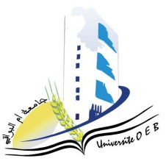

Larbi Ben M’Hidi-Oum El Bouaghi university
Faculty of Exact Sciences and Natural and Life Sciences

Department: Sciences of Matter

Field: Physics
Specialty: 2nd year physics degree

day and date | Hour | Module | Teacher | Place
Sunday  25-01-2026 | 14h00-14h30 | physical crystallography | Bouasida | F3
Sunday  25-01-2026 | 11h00-11h30 | Series and differential equations | Bragdi | F3
Tuesday  27-01-2026 | 11h00-11h30 | English | Mazouze | F3
Wednesday  28-01-2026 | 11h00-11h30 | Analytical Mechanics | Mellouki | F3
Wednesday  28-01-2026 | 11h30-12h00 | Geometric Optics and Physics | Lakehal | F3
Thusday  29-01-2026 | 11h00-11h30 | vibrations and oscillations | Gasmi | F3
Thusday  29-01-2026 | 11h30-12h00 | Numerical Methods and Programming | Laimache | F3
Academic Year : 2025-2026

