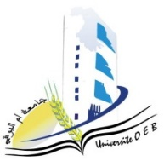
Larbi Ben M’Hidi University –Oum El Bouaghi
Faculty of Exact Sciences and Natural and Life Sciences
Department: Matter Sciences
2nd year Chemistry degree

Day and date | Time | Subject | Teacher | room
Sunday  25-01-2026 | 11h30-12h00 | Physico-Chemical Analysis Techniques | zater | A09
Sunday  25-01-2026 | 11h00-11h30 | Mineral Chemistry | Bouhanghel | A09
monday  26-01-2026 | 11h00-11h30 | Numerical Methods and Programming | ziar | A09
Tuesday  27-01-2026 | 11h00-11h30 | Applied Mathematics | Laich | A09
Tuesday  27-01-2026 | 11h00-11h30 | English | Mazouze | A09
Wednesday  29-01-2026 | 09h00-09h30 | Vibrations, Waves and Optics | Gasmi | A09
Wednesday  29-01-2026 | 13h00-13h30 | Organic Chemistry 1 | Cherriat | A09

