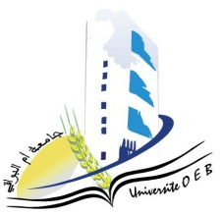
Larbi Ben M'Hidi-Oum El Bouaghi University
Faculty of Exact, Natural and Life Sciences
Department: Science of Matter

1st year Matter Science

Day and date | Time | Subject | Teacher | room
sunday  25-01-2026 | 08h300-09h30 | Computer science | Bounab | Amphi  10
monday  26-01-2026 | 08h30-09h30 | Chemistry 1 | Benahmed | Amphi  10
monday  26-01-2026 | 11h30-12h30 | PW Chemistry | Zandaoui | Amphi  10
monday  26-01-2026 | 10h00-11h00 | Mathematics 1 | Guechi | Amphi  10
Tuesday  15-01-2026 | 08h30-09h30 | English | Bensalah | Amphi  10
Tuesday  27-01-2026 | 08h30-09h30 | Physics 1 | Farah | Amphi  10
Tuesday  27-01-2026 | 09h30-10h30 | Academic working method | Goumidane | Amphi  10
Tuesday  27-01-2026 | 10h30-11h30 | PW Physics | Lakhal | Amphi  10

