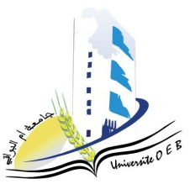

Larbi Ben M’Hidi-Oum El Bouaghi university
Faculty of Exact Sciences and Natural and Life Sciences

Department : Sciences of Matter

Exam Schedule Of First Semester

Field: Physics

Specialty: Applied Physics Master's Degree 2

Day and date | Hour | Module | Teacher | Room
Saturday  10-01-2026 | 13h00-14h30 | Photovoltaic Conversion | MOUALKIA | D 6
Sunday  11-01-2026 | 13h00-14h30 | Analog Circuit Design | HOBAR | D 6
Tuesday  13 -01-2026 | 13h00-14h30 | Heterojunctions And Dielectrics | MOUALKIA | D 6
Wednesday  14-01-2026 | 13h00-14h30 | Photonic Materials and Components | BORDJI | D 6
Thursday  15-01-2026 | 13h00-14h30 | Physics of Components and Nanostructures | Azizi C | D 6
Saturday  17-01-2026 | 13h00-14h30 | Bibliographic search | MOUALKIA | D 6
Sunday  18-01-2026 | 13h00-14h30 | Systèmes de Telecommunications systems, RF and microwave devices | HAMMOUDA | D 6
Monday  19-01-2026 | 13h00-14h30 | Advanced MOS Devices | HOBAR | D 6

Academic Year : 2025-2026

