University of Larbi Ben M’Hidi-Oum El Bouaghi
Faculty of Exact Sciences and Natural and Life Sciences
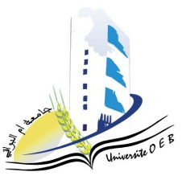
Department: Material Science
Schedule for Semester 3 Exams
Field: Chemistry
Specialty: Analytical Chemistry

Master's Degree 2

All exams occur from 13:00 to 14:30 in room D13
Day and date | Time | Subject | Teacher | Room
Saturday  10-01-2026 | 13 :00-14 :30 | Environmental Aspects | Hamada | D 04
Sunday  11-01-2026 | 13 :00-14 :30 | Analysis Techniques in Electrochemistry | Hafsi | D04
Tuesday  13-01-2026 | 13 :00-14 :30 | Applied Numerical Methods | Laich | D 04
Wednesday  14-01-2026 | 13 :00-14 :30 | Organization and Management of Companies | Habbes | D 04
Thursday  15-01-2026 | 13 :00-14 :30 | Analyses Related to the Environment II | Gherraf | D 04
Saturday  17-01-2026 | 13 :00-14 :30 | PersonalDocumentary Research Work | Nacer | D 04
Sunday  18-01-2026 | 13 :00-14 :30 | Spectrometry and Imaging Instrumentation II | Azizi, S | D 04
Monday  19-01-2026 | 13 :00-14 :30 | Health and Safety | DemmeneDebbih | D 04
Academic year2025-2026.

