Larbi Ben M'HidiUniversity - Oum El Bouaghi
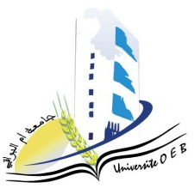
Faculty of Exact Sciences and Natural and Life Sciences
Department: of Science of matter
Semester 1 Exam Schedule
Field of Study:Chemistry
Specialty: Pharmaceutical Chemistry

Master's Degree 2

Day and date | Time | Subject | Teacher | Room
Saturday  10-01-2026 | 13H00-14H30 | Bioethic | allaoua | D 3
Sunday  11-02-2026 | 13H00-14H30 | Industrialhygiene and safety in pharmaceutical sites | Hazourli | D3
Tuesday  1301-2026 | 13H00-14H30 | Microbiology | Saouli | D 3
Wednesday  14-01-2026 | 13H00-14H30 | Marketing authorization (AMM) | Mahdi | D 3
Thursday  15-01-2026 | 13H00-14H30 | Chemistry of naturalproducts | SID | D3
Saturday  17-01-2026 | 13H00-14H30 | Chemistry of drugs | Demmene Debbih | D 3
sunday  18-01-2026 | 13H00-14H30 | Economy and business management | Habbes | D 3

Academic year2025-2026.

