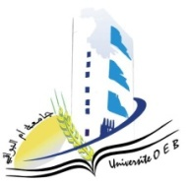
Larbi Ben M’Hidi University – Oum El Bouaghi
Faculty of Exact Sciences and Natural and Life Sciences
Department: Material Science
Exam Schedule – Semester 1
Field of study: Chemistry]
Specialty: Materials Chemistry Master's Degree 2

Day and date | Time | Subject | Teacher | room
Saturday  10-01-2026 | 13H00-14H30 | Personal bibliographic research work | Berrah | D 8
Sunday  11-01-2026 | 13H00-14H30 | Materials characterization method 2 | Bouacida | D 8
Tuesday  13-01-2026 | 13H00-14H30 | English | Berrah | D 8
Wednesday  14-01-2026 | 13H00-14H30 | Applied numerical methods | Laiche | D 8
Thursday  15-01-2026 | 13H00-14H30 | Introduction to research | Zendaoui | D 8
Saturday  17-01-2026 | 13H00-14H30 | Civil law | Haouili | D 8

Academic year2025-2026.

