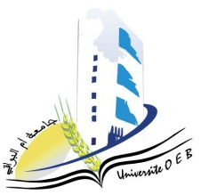
Larbi Ben M’HidiUniversity - Oum El Bouaghi
Faculty of Exact Sciences and Natural and Life Sciences
Department : Material Science

Semester 5 Exam Schedule

Field : Physics

Specialty: Materials Physics Master's Degree 2

Day and date | time | Subject | Teacher | room
Saturday  10-01-2026 | 13H00-14H30 |  | boudabe | D 5
  Nanotehnology
Sunday  11-01-2026 | 13H00-14H30 | Physics of defects | mecif | D5
Tuesday  13-01-2026 | 13H00-14H30 | Scientific processes and didactics | mahdjoub | D5
Wednesday  14-01-2026 | 13H00-14H30 | english | bensalah | D 5
Thursday  15-01-2026 | 13H00-14H30 | Thermodynamics and statistical physics | Khanchoul | D 5
Saturday  17-01-2026 | 13H00-14H30 | Methods of analysis and characterization of materials | mahdjoub | D 5
Sunday  18-01-2026 | 13H00-14H30 | Applied numerical methods | laich | D 5

Academic year2025-2026.

