Larbi Ben M'HidiUniversity - Oum El Bouaghi
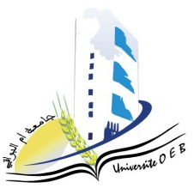
Faculty of Exact Sciences and Natural and Life Sciences
Department: of Science of matter

Semester 1 Exam Schedule

Field of Study:Chemistry

Specialty: Pharmaceutical Chemistry
Master 1

Day and date | Time | Subject | Teacher
Saturday  10-01-2026 | 09H00-10H30 | Pharmaceutical legislation and ethics | ABABSA Z
Sunday  11-01-2026 | 09H00-10H30 | Spectroscopic Analysis Methods | Azizi S
Tuesday  13-01-2026 | 09H00-10H30 | Drug Technology – Galenic Pharmacy | ABABSA Z
Wednesday  14-01-2026 | 09H00-10H30 | Biochemistry – Microbiology | Saouli
Thursday  15-01-2026 | 09H00-10H30 | PW Intelligence artificielle et Machine Learning 1 | Bensiah
Saturday  17-01-2026 | 09H00-10H30 | Pw Physico chemical Extraction and Analysis | Berahel
Sunday  18-01-2026 | 09H00-10H30 | Molécules bioactives - Méthodes d’extraction | Zater
Monday  19-01-2026 | 09H00-10H30 | Chemical Reactors and Bioreactors | Bouasida
Tuesday  20-01-2026 | 09H00-10H30 | Heterocyclic Organic Chemistry | SID

Student groups are assigned to exam rooms as follows:

Student Group | Room
Group : 01 | D 07
Group : 02 | D 06
Academic Year 2025-2026.

