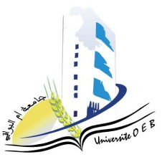
Larbi Ben M’Hidi University – Oum El Bouaghi
Faculty of Exact Sciences and Natural and Life Sciences
Department: Material Science
Exam Schedule – Semester 1
Field of study: Chemistry]
Specialty: Analytical Chemistry Master's Degree 1
Day and date | Time | Subject | Teacher | Room
Saturday  10-01-2026 | 09H00-10H30 | PW ChromatographicAnalysisMethods | Golia | D 4
Sunday  11-01-2026 | 09H00-10H30 | Chemistry–Physics of Surfaces and Interfaces | Hazourli | D 4
Tuesday  13-01-2026 | 09H00-10H30 | BibliographicSynthesis and Writing | Nacer | D 4
Wednesday  14-01-2026 | 09H00-10H30 | Analytical Electrochemistry | Anana | D 4
Thursday  15-01-2026 | 09H00-10H30 | PW Programming in Analytical Chemistry | Bensiah | D 4
Saturday  17-01-2026 | 09H00-10H30 | Environmental Analyses | Hamada | D 4
Sunday  18-01-2026 | 09H00-10H30 | PW Electrochemical Applications | Hazourli | D 4
Monday  19*01-2026 | 09H00-10H30 | PW Artificial Intelligence and Machine Learning 1 | Bensiah | D 4
Tuesday  20-01-2026 | 09H00-10H30 | Chromatographic Analysis Techniques | Nacer | D 4
Wednesday  21-01-2026 | 09H00-10H30 | Multi‑equilibria in Solution | Hamada | D 4
Academic year2025-2026

