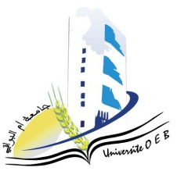
Larbi Ben M’HidiUniversity - Oum El Bouaghi
Faculty of Exact Sciences and Natural and Life Sciences
Department : Material Science

Semester 5 Exam Schedule

Field : Physics

Specialty: Materials Physics Master's Degree 1

Jour et date | Time | Subject | Teacher | room
Saturday  10-01-2026 | 09H00-10H30 | Artificial intelligence and machine learning 1 | benSaihe | D 05
Sunday  11-01-2026 | 09H00-10H30 | Physics of semiconductors | hobar | D05
tuesday  13-01-2026 | 09H00-10H30 | Physical metallurgy | Goumeidane | D 05
Wednesday  14-01-2026 | 09H00-10H30 | exploration of free and open source software | Khanchoule | D 05
Thursday  15-01-2026 | 09H00-10H30 | radiation-matter | malouki | D 05
saturday  17-01-2026 | 09H00-10H30 | Dielectric and magnetic materials | Khanchoule | D 05
sunday  18-01-2026 | 09H00-10H30 | Advanced Solid State Physics | Benhamla | D 05
Monday  19-01-2026 | 09H00-10H30 | Signal processing | Laib | D 05
tuesday  20-01-2026 | 09H00-10H30 | Physical Production and storage of hydrogen/ | Khanchoul | D 05

Academic year2025-2026

