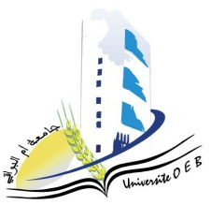
Larbi Ben M’Hidi University – Oum El Bouaghi
Faculty of Exact Sciences and Natural and Life Sciences
Department: Matter Science
Semester 6 Examination Schedule
Program: Physics
Specialty: Fundamental Physics
Year: $3^{rd}$Year
Day & Date | Time | Subject | Instructor | Room
Saturday  10/01/2025 | 09:00–10:30 | Acoustics | Bordji | D 1
Sunday  11/01/2025 | 09:00–10:30 | Quantum Mechanics II | Zeroual | D 1
Tuesday  13/01/2025 | 09:00–10:30 | Digital Physics | Boudjamaa | D 1
Wednesday  14/01/2025 | 09:00–10:30 | Entrepreneurship | Habes | D 1
Thursday  15/01/2025 | 09:00–10:30 | Special Relativity | Abdellaoui | D 1
Saturday  17/01/2025 | 09:00–10:30 | Statistical Physics | Merad | D 1
Sunday  18/01/2025 | 09:00–10:30 | Special Functions of Physics | Zeroual | D 1
Monday  19/01/2026 | 09:00–10:30 | Semiconductor | Kalla | D 1
— | —

