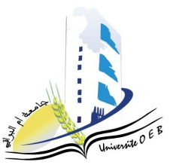
University of Larbi Ben M’Hidi-Oum El Bouaghi
Faculty of Exact Sciences and Natural and Life Sciences
Departement: Sciences Of Matter

Planning of semester 5 exams

Field of study: chemistry
Specialization: pharmaceutical chemistry

3rd year

Day and date | Hour | Matter | Teacher | Place
Saturday  10-01-2026 | 09H00-10H30 | PW : ElectrochemicalAnalysisMethods | Hazourli | Amphi  10
Sunday  11-01-2026 | 09H00-10H30 | SpectroscopicMethods of Analysis | Hafsi | Amphi  10
Tuesday  13-01-2026 | 09H00-10H30 | PW Pharmacology-Toxicology | Mahdi | Amphi  10
Wednesday  14-01-2026 | 09H00-10H30 | Entrepreneurship | Habes | Amphi  10
Thursday  15-01-2026 | 09H00-10H30 | Pharmaceutical OrganicChemistry | Berhail | Amphi  10
Saturday  17-01-2026 | 09H00-10H30 | Introduction to Knowledge of Medicine | Ababsa | Amphi  10
Sunday  18-01-202 | 09H00-10H30 | Advanced OrganicChemistry I | Lafrada | Amphi  10

Academic Year 2025-2026

