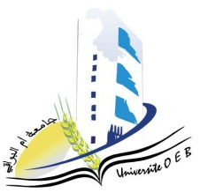
Larbi Ben M'Hidi-Oum El Bouaghi University

Faculty of Exact Sciences and Natural and Life Sciences

Department: Materials Science

Semester 5 Examination Schedule

Field of study: Chemistry

Specialisation: Fundamental Chemistry 3rd year

Day and date | Time | Matter | Teacher | Room
Saturday  10-01-2026 | 09H00-10H30 | Materials Chemistry | bouchane | Amphi  09
Sunday  11-01-2026 | 09H00-10H30 | Molecular Spectroscopy | zouchoune | Amphi  09
Tuesday  13-01-2026 | 09H00-10H30 | Thermodynamics of solutions | hamimed | Amphi  09
Wednesday  14-01-2026 | 09H00-10H30 | Entrepreneurship | habes | Amphi  09
Thursday  15-01-2026 | 09H00-10H30 | Analytical Chemistry | bouchane | Amphi  09
Saturday  17-01-2026 | 09H00-10H30 | Organic Chemistry | Allaoua | Amphi  09

University Year 2025-2026.

