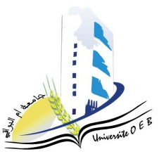
Larbi Ben M’HidiUniversity - Oum El Bouaghi
Faculty of Exact Sciences and Natural and Life Sciences
Department : Material Science

Semester 5 Exam Schedule

Field : Physics

Specialty: Materials Physics 3rd year

Day and date | Time | Subject | Teacher | Room
Saturday  10-01-2026 | 09H00-10H30 | Acoustic | Bordji | D 02
Sunday  11-01-2026 | 09H00-10H30 | Quantum mechanics 2 | Abdalaoui | D 02
Tuesday  13-01-2026 | 09H00-10H30 | Numeric alanalysis | Laiche | D 02
Wednesday  14-01-2026 | 09H00-10H30 | Entrepreneurship | Habes | D 02
Thursday  15-01-2026 | 09H00-10H30 | Statistical physic | Merad | D 02
Saturday  17-01-2026 | 09H00-10H30 | Component Electronics | Bordji | D 02
Sunday  18-01-2026 | 09H00-10H30 | Solid state physics 1 | Benhamla | D 02
Monday  19*01-2026 | 09H00-10H30 | Mathematics for Physics | Hamouda | D 02

Academic Year 2025-2026.

