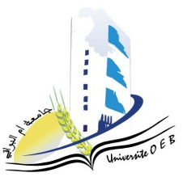

Larbi Ben M’Hidi-Oum El Bouaghi university
Faculty of Exact Sciences and Natural and Life Sciences

Department: Sciences of Matter

Exam Schedule Of Third Semester

Field: Physics
Specialty: 2nd year physics degree

day and date | Hour | Module | Teacher | Place
Saturday  10-01-2026 | 13h00-14h30 | physical crystallography | Bouasida | Amphi  10
Sunday  11-01-2026 | 13h00-14h30 | Series and differential equations | Bragdi | Amphi  10
Tuesday  13-01-2026 | 13h00-14h30 | English | Mazouze | Amphi  10
Wednesday  14-01-2026 | 13h00-14h30 | Analytical Mechanics | Mellouki | Amphi  10
Thusday  15-01-2026 | 13h00-14h30 | Numerical Methods and Programming | Laimache | Amphi  10
Saturday  17-01-2026 | 13h00-14h30 | vibrations and oscillations | Gasmi | Amphi  10
Sunday  18-01-2026 | 13h00-14h30 | Geometric Optics and Physics | Lakehal | Amphi  10
Academic Year : 2025-2026

