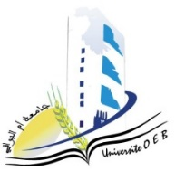
Larbi Ben M’Hidi University –Oum El Bouaghi
Faculty of Exact Sciences and Natural and Life Sciences
Department: Matter Sciences
Exam Schedule of Semester 3
2nd year Chemistry degree

date | Hour | Matter | Teachers | Place
sunday  04-01-2026 | 10h45-12h15 | Physico-Chemical Analysis Techniques 1 | Zater | D2
sunday  04-01-2026 | 14h15-15h45 | Numerical Methods and Programming | ziar | D2
Monday  05-01-2026 | 10h45-12h15 | Mineral Chemistry | Bouhangel | D2
Monday  05-01-2026 | 14h15-15h45 | Organic Chemistry 1 | Chereit | D2

Academic Year 2025-2026.

