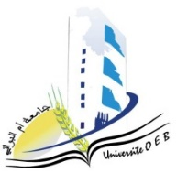
Larbi Ben M’Hidi University –Oum El Bouaghi
Faculty of Exact Sciences and Natural and Life Sciences
Department: Matter Sciences
Exam Schedule of Semester 3
2nd year Chemistry degree

Day and date | Time | Subject | Teacher
Saturday  10-01-2026 | 13h00-14h30 | Numerical Methods and Programming | ziar
Sunday  11-01-2026 | 13h00-14h30 | Mineral Chemistry | Bouhanghel
Tuesday  13-01-2026 | 13h00-14h30 | Physico-Chemical Analysis Techniques | zater
Wednesday  14-01-2026 | 13h00-14h30 | Applied Mathematics | Laich
Thursday  15-01-2026 | 13h00-14h30 | English | Mazouze
Saturday  17-01-2026 | 13h00-14h30 | Vibrations, Waves and Optics | Gasmi
Sunday  18-01-2026 | 13h00-14h30 | Organic Chemistry 1 | Cherriat
Student groups are allocated to examination rooms as follows:

Group of students | room
Groupe : 01+ 02 | Amphi 09
Academic year2025-2026

