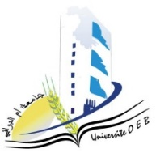
Larbi Ben M’Hidi University –Oum El Bouaghi
Faculty of Exact Sciences and Natural and Life Sciences
Department: Matter Sciences
Exam Schedule of Semester 3
2nd year Physics degree

date | Hour | Matter | Teachers | Place
sunday  04-01-2026 | 10h45-12h15 | physical crystallography | Bouasida | D 3
sunday  04-01-2026 | 14h15-15h45 | vibrations and oscillations | gasmi | D 3
Monday  05-01-2026 | 10h45-12h15 | Analytical Mechanics | Mellouki | D 3
Monday  05-01-2026 | 14h15-15h45 | Numerical Methods and Programming | laimache | D 3
Tuesday  06-01-2026 | 10h45-12h15 | Geometric Optics and Physics | Lakehal | D 3
Tuesday  06-01-2026 | 14h15-15h45 | Series and differential equations | Bragdi | D 3

Academic Year 2025-2026.

