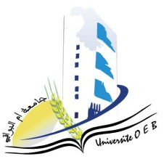
Larbi Ben M'Hidi-Oum El Bouaghi University
Faculty of Exact, Natural and Life Sciences
Department: Science of Matter
Semester 1 Exam Schedule
1st year Matter Science

Day and date | Time | Subject | Teacher | room
sunday  04-01-2026 | 09h00-10h30 | Mathematics 1 | Guechi | D 1
sunday  04-01-2026 | 12.h30-14h00 | Anglais 1 | bensalah | D 1
Monday  05-01-2026 | 09h00-10h30 | Chemistry 1 | Benahmed | D 1
Monday  05-01-2026 | 12.h30-14h00 | Computer science | Bounab | D 1
Tuesday  06-01-2026 | 09h00-10h30 | Physics 1 | Farah | D 1
Tuesday  06-01-2026 | 12.h30-14h00 | Academic working method | Goumidane | D 1
wednesday  07-01-2026 | 09h00-10h30 | PW Physics | Lakhal | D 1
Thursday  08-01-2026 | 09h00-10h30 | PW Chemistry | Zandaoui | D 1

Academic year2025-2026.

