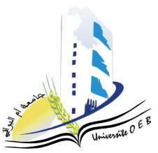**Larbi Ben M'Hidi-Oum El Bouaghi University**

**Faculty of Exact, Natural and Life Sciences**

**Department: Science of Matter**

**Exam Schedule for Semester 3**

**Field: Physics**

**Specialisation: Applied Physics**

**Master 2**

|  |  |  |  |  |
| --- | --- | --- | --- | --- |
| **Day and date** | **Time** | **Matter** |  | **ROOM** |
| Tuesday  28-01-2025 | 09H30-10H00 | Bibliographic search | Hebbir | E 12 |
| Tuesday  28-01-2025 | 11H00-11H30 | Physics of Components and Nanostructures | AZIZI C | E 12 |
| Tuesday  28-01-2025 | 11H30-12H00 | Analog Circuit Design  Advanced MOS Devices | HOBAR | E 12 |
| Tuesday  28-01-2025 | 12H30-13H00 | Photonic Materials and Components | BORDJI | E 12 |
| Tuesday  28-01-2025 | 10H00-10H30 | Heterojunctions And Dielectrics  Photovoltaic Conversion | MOUALKIA | E 12 |
| Tuesday  28-01-2025 | 12H00-12H30 | systems, RF and microwave devices | HAMMOUDA | E 12 |

Academicyear2024-2025