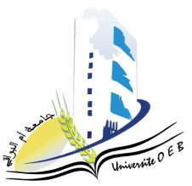**Larbi Ben M'Hidi-Oum El Bouaghi University**

**Faculty of Exact, Natural and Life Sciences**

**Department: Science of Matter**

**Consultation Schedule for Semester 3**

**Field: Physics**

**Speciality: Physics of materials**

**Master 2**

|  |  |  |  |  |
| --- | --- | --- | --- | --- |
| **Day and date** | **Time** | **matter** | **matter** | **room** |
| Sunday  26-01-2025 | 09H00-09H30 | Physics of defects | MECIF | E 12 |
| Sunday  26-01-2025 | 09H30-10H00 | Nanotechnology 2 | Azizi ch | E 12 |
| Sunday  26-01-2025 | 10H00-10H30 | English | BENSALAH | E 12 |
| Monday  27-01-2025 | 10H00-10H30 | Methods of analysis and characterization of materials  Scientific processes and didactics | MAHJOUB | E 12 |
| Monday  27-01-2025 | 11H 30-12H00 | Applied numerical methods | Laich | E 12 |
| Monday  27-01-2025 | 12H30-13H00 | Thermodynamics and statistical physics | KHENCHOUL | E 12 |

# Academic year2024-2025.