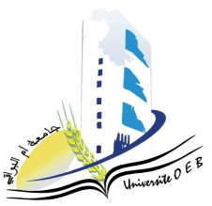**Larbi Ben M'Hidi-Oum El Bouaghi University**

**Faculty of Exact, Natural and Life Sciences**

**Department: Science of Matter**

**Consultation Schedule Semester 3**

**Subject: Chemistry**

**Speciality: Pharmaceutical Chemistry**

**Master 2**

|  |  |  |  |  |
| --- | --- | --- | --- | --- |
| **Day and date** | **Time** | **matter** | **matter** | **room** |
| Sunday  26-01-2025 | 12H30-13H00 | Industrial hygiene and safety in pharmaceutical sites | HAZOURLI | D9 |
| Sunday  26-01-2025 | 13H00-13H30 | Bioethics | Allaoua | D9 |
| Monday  27-01-2025 | 09H00-09H30 | Chemistry of natural products | SID | **Amphi 09** |
| Monday  27-01-2025 | 10H00-10H30 | MCHPH17: Marketing authorization (MA) | MAHDI | **Amphi 09** |
| Monday  27-01-2025 | 11H00-11H30 | Microbiology | SAOULI | **Amphi 09** |
| Monday  27-01-2025 | 11H 30-12H00 | Economics and business management | HABBES | **Amphi 09** |
| Monday  27-01-2025 | 13H00-13H 30 | Chemistry of drugs | DAMMENE DEBBIH | **Amphi 09** |