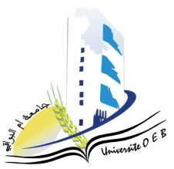**University of Larbi Ben M’Hidi-Oum El Bouaghi**

**Faculty of Exact Sciences and Natural and Life Sciences**

**Department: Material Science**

**Consultation Schedule for Semester 3**

**Field: Chemistry**

**Speciality: Chemistry of materials**

**Master's Degree 2**

|  |  |  |  |  |
| --- | --- | --- | --- | --- |
| **Day and date** | **Time** | **Matter** | **Teacher** | **room** |
| Sunday  26-01-2025 | 09h30-10h30 | Materials characterization method 2 | BOUACIDA | C1 |
| 09H00-09H30 | Applied numerical methods | ghernoug | D 2 |
| Sunday  26-01-2025 | 11H00-11H30 | Introduction to research | Zandaoui | D2 |
| Monday  27-01-2025 | 09H00-09H30 | Civil Law | Kherchi | D 09 |
| Monday  27-01-2025 | 10H30-11H00 | Anglais | Anglais | D 16 |
| Monday  27-01-2025 | 11H00-11H30 | Personal bibliographic research work | BERRAH | D16 |