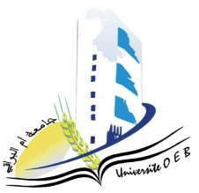University of Larbi Ben M’Hidi-Oum El Bouaghi

Faculty of Exact Sciences and Natural and Life Sciences

**Department:** Material Science

**Consultation Schedule for Semester 3**

**Field: Chemistry**

**Specialty: Analytical Chemistry**

**Master's Degree 2**

|  |  |  |  |  |
| --- | --- | --- | --- | --- |
| **Day and date** | **Time** | **Matter** | **Teachers** | **ROOM** |
| Sunday  19-01-2025 | 09H00-09H30 | Spectrometry and imaging instrumentation II- | AZIZI S | D 15 |
| 09H30-10H30 | Environmental aspects | HAMADA | D 15 |
| 10H30-11H00 | Applied numerical methods | LAICH |  |
| Sunday  19-01-2025 | 11H30-12H15 | Personal documentary research work | NACER | D 15 |
| Sunday  19-01-2025 | 12H15-13H00 | Environmental analyzes II-SAE14 | Gherraf | D 15 |
| Monday  26-01-2025 | 10H30-10H30 | Analysis techniques in electrochemistry | HAFSI | D 15 |
| Monday  26-01-2025 | 11H30-12H00 | Business organization and management | HABBES | D 15 |
| 12H00-12H30 | Health and safety food | DEMMENE DEBBIH | D 15 |

**Academic year 2024-2025.**