**Larbi Ben M'Hidi-Oum El Bouaghi University**

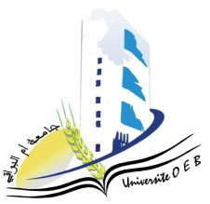**Faculty of Exact, Natural and Life Sciences**

**Department : Science of Matter**

**Consultation Schedule Semester 1**

**Field: Physics**

**Speciality: Applied physics**

**Master 1**

|  |  |  |  |  |
| --- | --- | --- | --- | --- |
| **Day and date** | **Time** | **Matter** | **Teachers** | **Room** |
| Sunday  19-01-2025 | 09H00-09H30 | Microwave | HAMOUDA | F 3 |
| Sunday  19-01-2025 | 10H00-10H30 | Matlab programming  Digital Modelling 1 | LAICHE | F3 |
| Sunday  19-01-2025 | 10H00-11H00 | Physics of semiconductor devices | MOUALKIA | F3 |
| Sunday  19-01-2025 | 11H00-11H30 | High voltage and insulating materials | ISMAIL | F3 |
| Sunday  19-01-2025 | 11H30-12H00 | English for Research | Bensalah | F3 |
| Sunday  19-01-2025 | 13H00-13H30 | Signal processing | YAZID | F3 |

**Academic year2024-2025.**