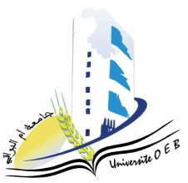Larbi Ben M’Hidi University –Oum El Bouaghi

 Faculty of Exact Sciences and Natural and Life Sciences

Department : Matter Sciences

**Consultation Schedule Semester 1**

**Field: Chemistry**

**Speciality: Pharmaceutical chemistry**

**Master 1**

|  |  |  |  |  |
| --- | --- | --- | --- | --- |
| **Day and date** | **Time** | **Matter** | **Teachers** | **ROOM** |
| Sunday  26-01-2025 | 09H00-09H30 | Computer sciences | Bouneb | D 17 |
| 09H30-10H00 | Analytical chemistry: Electrochemical methods and extraction and separation | ANANA |
| 10H00-10H30 | Organic chemistry and reaction mechanism | GOLEA |
| Monday  27-01-2025 | 10H00-10H30 | English | KOUCHARI | D 17 |
| Monday  27-01-2025 | 10H00-10H30 | Knowledge of the drug | MAHDI | D 17 |
| Monday  27-01-2025 | 11H00-11H30 | Natural plant substances, pharmacognosy | SID |
| 11H30-12H00 | Toxicology – pharmacology | BERHAIL |
| 13H30-14H00 | Pharmaceutical law  Galenic pharmacy and biopharmacy | ABABSA Z |

Academic year2024-2025