**Larbi Ben M’Hidi University –Oum El Bouaghi**

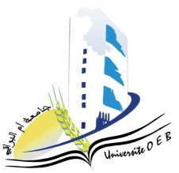**Faculty of Exact Sciences and Natural and Life Sciences**

**Department: Matter Sciences**

**Exam Schedule Semester 1**

**Field: Chemistry**

**Speciality: chemistry of materials**

**Master 1**

|  |  |  |  |  |
| --- | --- | --- | --- | --- |
| **Jour et date** | **Time** | **Matter** | **Teachers** | **room** |
| Sunday  26-01-2025 | 09H00-09H30 | Transfer phenomena | GHERRAF | D 16 |
| 09H30-10H30 | Physicochemical properties of materials  Materials  Pw Physicochemical properties of materials | BOUHENGUEL | D 16 |
| 10H30-11H00 | Surface chemistery | HAZOURLI | D 16 |
| Sunday  26-01-2025 | 11H00-11H30 | Computer programming | Zendaoui | D 16 |
| Sunday  26-01-2025 | 11H00-12H00 | Quantum chemisetry | Bounab | D 16 |
| Monday  27-01-2025 | 09H00-09H30 | Relations between the university and the socio-economic sector | HABBES | D 16 |
| 09H30-10H30 | Coordination Chemistry | BENOSMANE | D 16 |
| 10H30-11H00 | English | KOUCHARI | D 16 |

**Academic year2024-2025.**