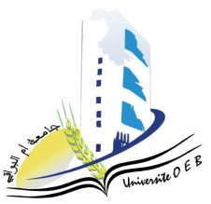Larbi Ben M’Hidi University –Oum El Bouaghi

Faculty of Exact Sciences and Natural and Life Sciences

Department: Matter Sciences

**Consultation Schedule Semester 1**

**Field: Chemistry**

**Speciality: Analytical chemistry**

**Master 1**

|  |  |  |  |  |
| --- | --- | --- | --- | --- |
| **Day and date** | **Time** | **Matter** | **Teachers** | **Room** |
| Sunday  26-01-2025 | 09H00-09H30 | Spectroscopic methods I | AZIZI S | D 15 |
| Sunday  26-01-2025 | 09H30-10H 30 | Materials characterization methods  Chromatographic Instrumentation | HAMADA | D 15 |
| Sunday  26-01-2025 | 10H30-11H00 | Méthodes chromatographiques I | LEFRADA | D 15 |
| Sunday  26-01-2025 | 11H30-12H15 | Statistics and chemometrics | NACER | D 15 |
| 12H15-13H00 | Separation methods | Gherraf | D 15 |
| Monday  27-01-2025 | 09H00-09H30 | Sampling and analysis methods | SAOULI | D 15 |
| 09H30-10H00 | English | KOUCHARI |

**Academic year2024-2025.**