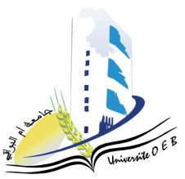**UniversitéLarbiBenM’Hidi-OumElBouaghi**

**Facultédessciencesexactesetsciencesdelanatureetdelavie**

**Département : Science de la matière**

**Consultation Schedule for Semester 1**

**Field : Physics**

**Speciality: Physics of materials**

**Master 1**

|  |  |  |  |  |
| --- | --- | --- | --- | --- |
| **Day and date** | **Time** | **Matter** | **Teacher** | **room** |
| Sunday  19-01-2025 | 09H00-09H30 | Semi conductor physics | KALLA | F5 |
| Sunday  19-01-2025 | 09H30-10H00 | Simulation methods in materials science | LABED | F5 |
| Sunday  19-01-2025 | 10H00-10H30 | Physical properties of materials | MECIF | F5 |
| Sunday  19-01-2025 | 10H30-11H00 | Practical work 1 | Benhamla | F5 |
| Sunday  19-01-2025 | 11H00-11H30 | radiation-matter interaction | MELLOUKI | F5 |
| Monday  20-01-2025 | 10H00-10H30 | phase transformations | Goumeidane | F5 |
| Monday  20-01-2025 | 10H30-11H00 | Management | HABBES | F5 |

**Academic year 2024-2025.**