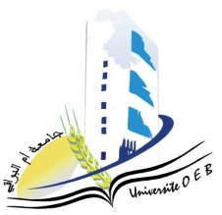**University of Larbi Ben M’Hidi-Oum El Bouaghi**

**Faculty of Exact Sciences and Natural and Life Sciences**

**Department: Material Science**

**consultation Schedule for Semester 5**

**Field: Physics**

**Speciality: Fundamental Physics**

**3rd year**

|  |  |  |  |  |  |
| --- | --- | --- | --- | --- | --- |
| **Day and date** | **Time** | **Matter** | **Teachers** | **room** | |
| Sunday  19-01-2025 | 09H00-10H30 | Quantum Mechanics II  Mathematics methods for physics | Zeroual | F1 | |
| Sunday  19-01-2025 | 10H30-10H30 | Restricted Relativity | Guesmia | F1 | |
| Sunday  19-01-2025 | 10H30-11H00 | Digital Physics | Labed | F1 | |
| Sunday  19-01-2025 | 11H00-11H30 | Physical course of semi-Cond. | Kalla | F1 |
| Sunday  19-01-2025 | 11H30-12H00 | Electromagnetic Waves | Abdellaoui | F1 | |
| Monday  20-01-2025 | 09H30-10H00 | Statistical physics | Merad | F1 | |
| Monday  20-01-2025 | 10H00-10H30 | English | Chaabna | F1 | |

**Année Universitaire 2024-2025.**