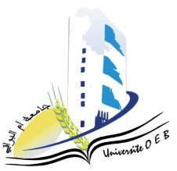**Larbi Ben M’Hidi University –Oum El Bouaghi**

**Faculty of Exact Sciences and Natural and Life Sciences**

**Department : Matter Sciences**

**Consultation Schedule Semester 5**

**Field: Chemistry**

**Speciality: Pharmaceutical chemistry**

**3rd year**

|  |  |  |  |  |
| --- | --- | --- | --- | --- |
| **Day and date** | **Time** | **Matter** | **Teachers** | **room** |
| Sunday  26-01-2025 | 09H00-09H30 | PW Synthesis of organic intermediates for bioactive molecules | Guerrah | D 13 |
| 09H30-10H00 | Spectroscopic analysis methods | HAFSI |
| 10H00-10H30 | Electrochemical analysis methods | HAZOURLI |
| 10H30-11H30 | Advanced organic chemistry I | LAFRADA |
| 11H30-12H00 | English | Garoui |
| Monday  27-01-2025 | 09H30-10H00 | Pharmacology-Toxicology | MAHDI | D 13 |
| 10H00-11H00 | introduction to knowledge of medicine | ABABSA | D 13 |
| 11H00-11H30 | Pharmaceutical organic chemistry | BERHAIL BOUDOUDA |