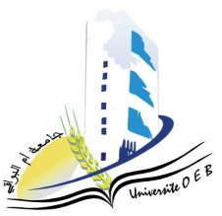**University of Larbi Ben M’Hidi-Oum El Bouaghi**

**Faculty of Exact Sciences and Natural and Life Sciences**

**Department: Material Science**

**Consultation schedule for Semester 5**

**Field: Chemistry**

**Speciality : Fundamental Chemistry**

**3rd year**

|  |  |  |  |  |
| --- | --- | --- | --- | --- |
| **Day et date** | **Time** | **Matter** | **Teacher** | **room** |
| Sunday  26-01-2025 | 09H00-09H30 | Cristallography | BERRAH | D 14 |
| Sunday  26-01-2025 | 09H30-10H30 | Chemistry of materials  Analytical Chemistry II | BOUCHENE | D 14 |
| Sunday  26-01-2025 | 10H30-11H30 | Organic Chemistry III  PW Organic Chemistry III | ALLAOUA | D 14 |
| Sunday  26-01-2025 | 11H30-12H00 | English | Garoui | D 14 |
| 13H00-13H30 | Quantum Chemistry II  PW Molecular modeling | ZOUCHOUNE B | D 14 |