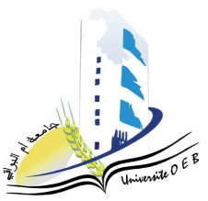

**University of Larbi Ben M’Hidi-Oum El Bouaghi**

**Faculty of Exact Sciences and Natural and Life Sciences**

**Department: Material Science**

**C consultation Schedule of the Semester 5 Exams  
Field: Physics**

**Specialty : Materials Physics  
3rd year**

|  |  |  |  |  |
| --- | --- | --- | --- | --- |
| **Day and date** | TIME | **Matter** | **Teachers** | **R00M** |
| Sunday  26-01-2025 | 09H00-09H30 | Mathematics for Physics | Laich | F2 |
| Sunday  26-01-2025 | 09H30-10H30 | PW Solid state physics 1  Solid state physics 1 | Benhamla | F2 |
| Sunday  26-01-2025 | 11H00-11H30 | Quantum mechanics 2 | Abdellaoui | F2 |
| Sunday  26-01-2025 | 11H30-12H30 | Electronic components  Acoustic | Bordji | F2 |
| Monday  27-01-2025 | 09H30-10H00 | Numerical analysis | **Dehilis** | F2 |
| Monday  27-01-2025 | 10H00-10H30 | Statistical physics | Merad | F2 |
| Monday  27-01-2025 | 10H30-11H00 | Software | Laib | F2 |
| Monday  27-01-2025 | 11H00-11H30 | English | chaabene | F2 |

**Année Universitaire 2024-2025.**