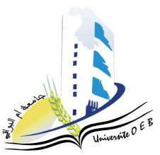**University of Larbi Ben M’Hidi-Oum El Bouaghi**

**Faculty of Exact Sciences and Natural and Life Sciences**

**Department: Material Science**

**Consultation Schedule Semester 3**

**Field: Chemistry**

**Speciality: Chemistry**

**2nd year Chemistry degree**

|  |  |  |  |  |
| --- | --- | --- | --- | --- |
| Day and date | Time | Matter | Teachers | room |
| Sunday  26-01-2025 | 09h00-09h30 | Applied Mathematics | Bourabta | **Amphi 09** |
| Sunday  26-01-2025 | 09h00-10h00 | Anglais | Kouchari | **Amphi 09** |
| Sunday  26-01-2025 | 10h00-10h30 | Organic Chemistry 1 | Cherite | **Amphi 09** |
| Sunday  26-01-2025 | 10h30-11h00 | Physico-Chemical Analysis Techniques I | Zater | **Amphi 09** |
| Sunday  26-01-2025 | 11h00-11h30 | Vibrations, Waves & Optic | Segheiri | **Amphi 09** |
| Sunday  26-01-2025 | 12h00-13h00 | Methods and Programming | Ziar | **Amphi 09** |
| Sunday  26-01-2025 | 13h00-13h30 | Mineral Chemistry | Zama | **Amphi 09** |

# Academic year2024-2025.